**SCREEN SHOTS**

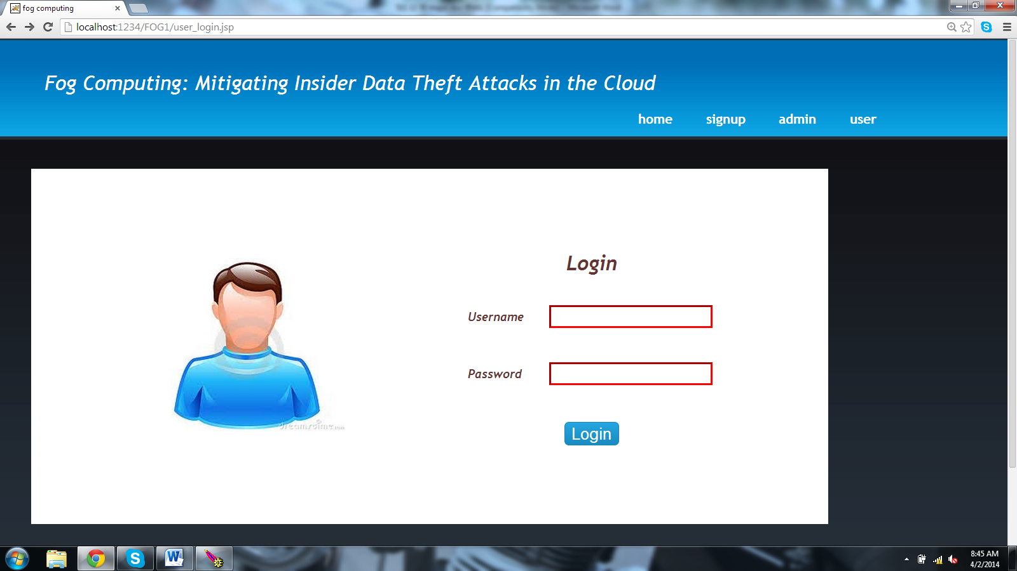

SS.5.1 User Login page

**Login screen:**

Enter User Name

Password

Validate on login: if Username and password does not match show a error message (hard code these for now)

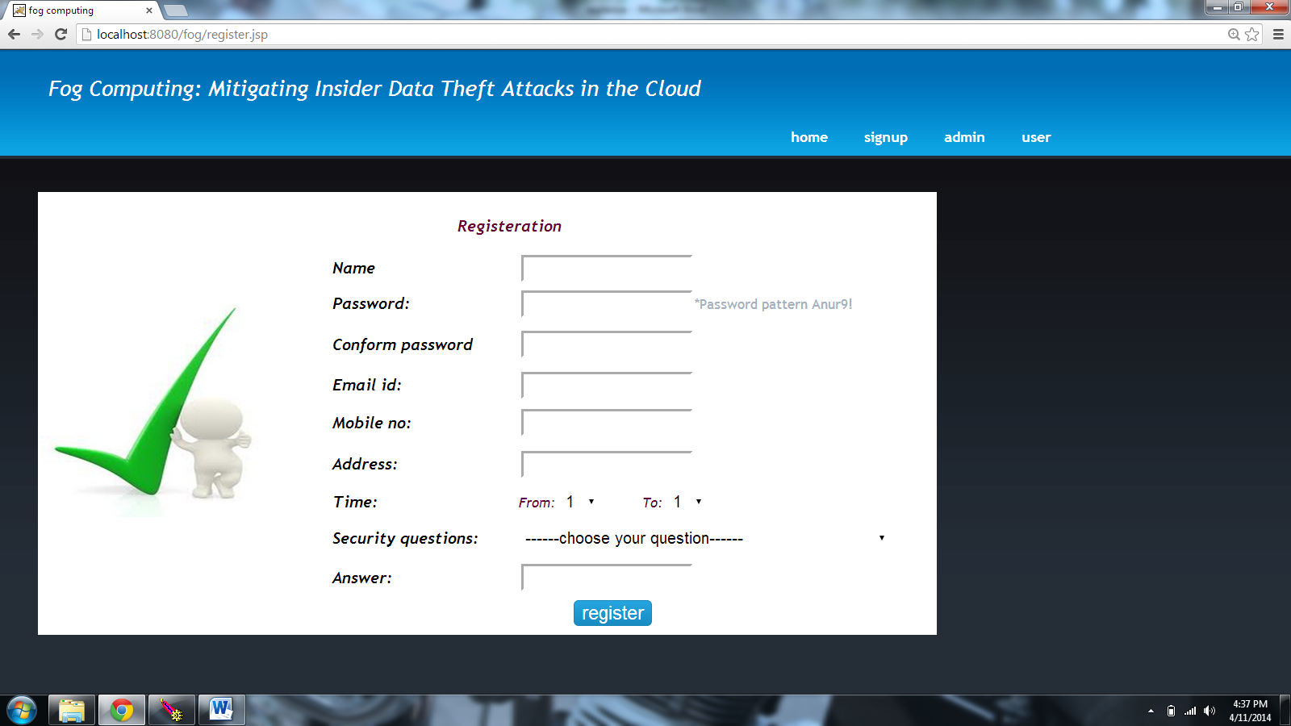

SS.5.2 Registration page

**Registration:** shows up when the user clicks on the signup link on home screen.

No empty fields /all the fields are mandatory.

Password : some generic rule (you decide)

Confirmation password : should match with the actual password

Email ID: generic mail id check (you decide)

Address: not more than few charecters (you decide)

Time: should be two drop downs with 24 hrs, with the validation of having from time less than to time

Security Questions: Should be five drop downs( with few random question for now,we’ll change after we get the actual ones)

Answers : (you decide)

Register: checks for all validations. And shows inline error messages if any error.

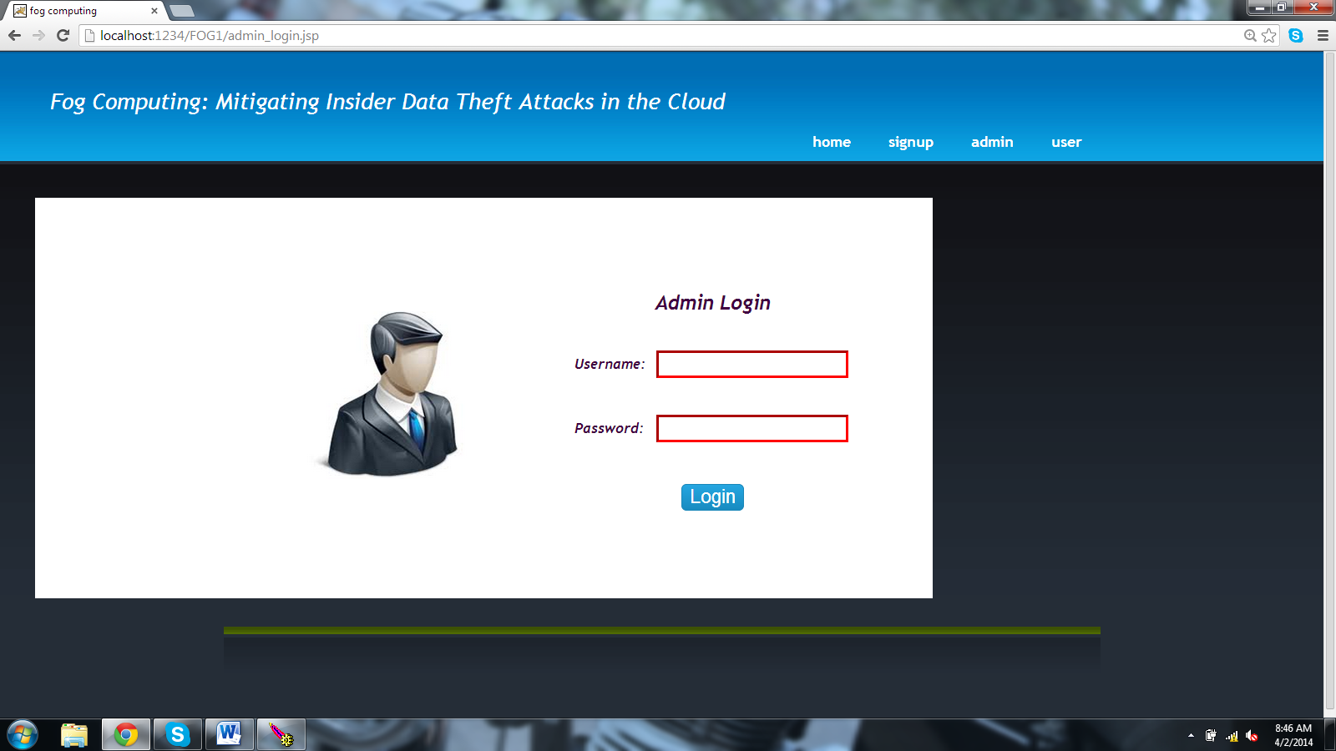

SS.5.3 Admin Login Page

**Admin Login**: on selecting the admin from the top panel in the home screen .same as the user login screes and its validations.(hard coding them for now).

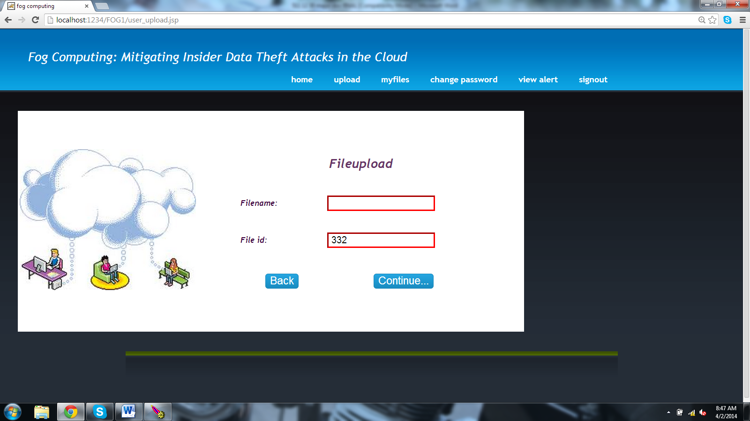

SS.5.4 User Filename Upload Page

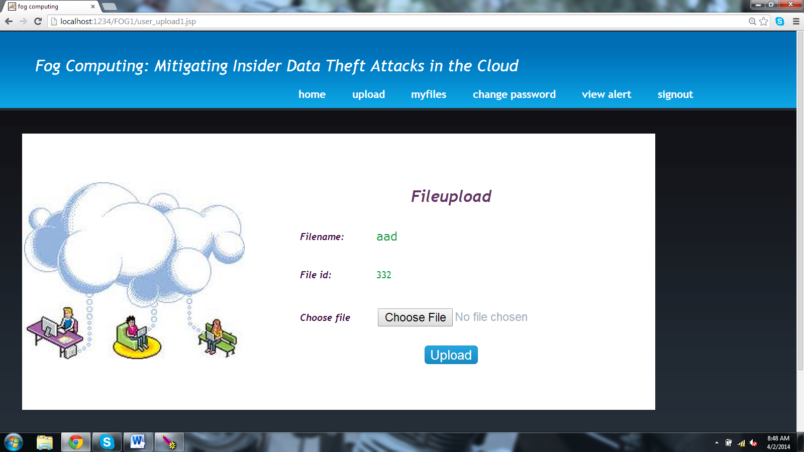

SS.5.5 Choose File to Upload

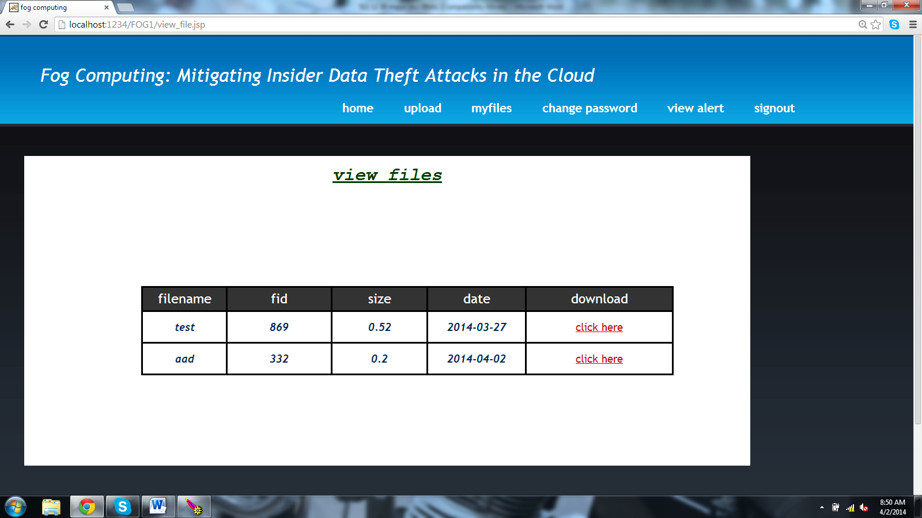

SS.5.6 Users Uploaded Files

This should be the landing page for the user showing his list of files and control panel(can be placed on top or to the left, which ever you feel better)

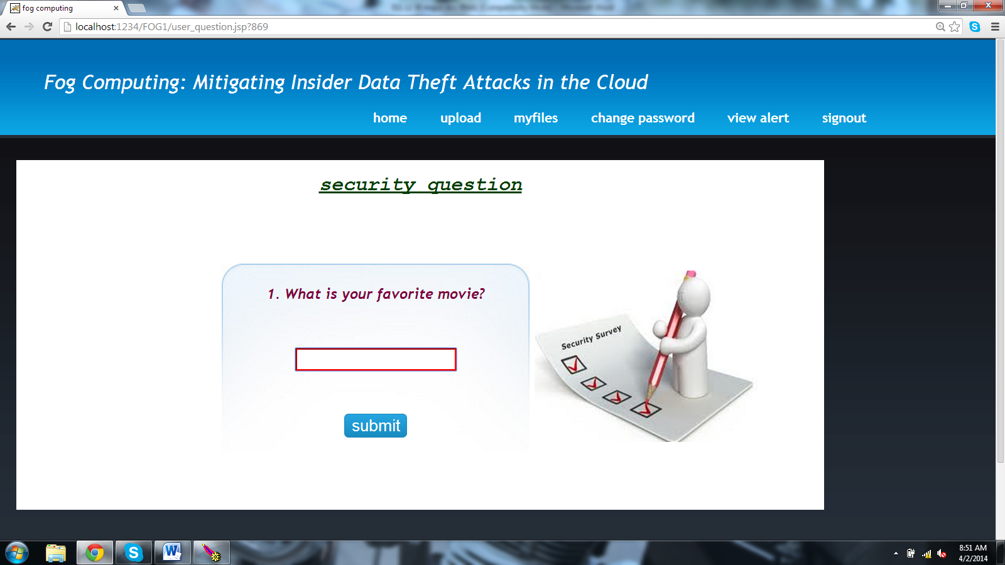

SS.5.7 User Security Question Page

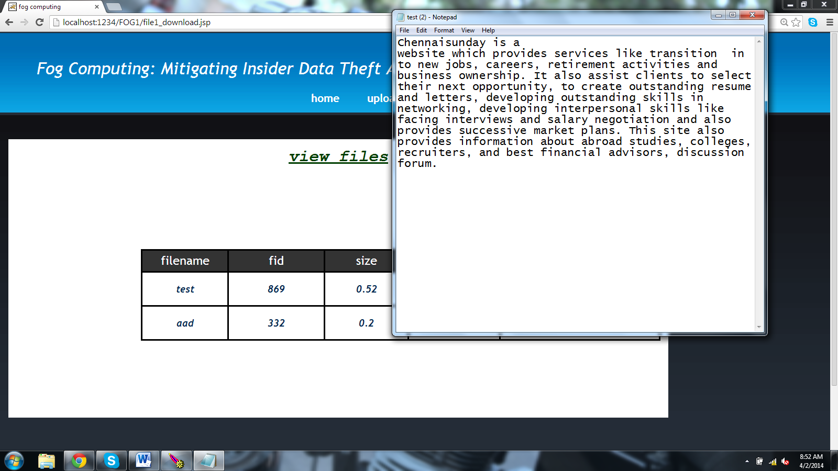

SS.5.8 User original file by giving correct security answer

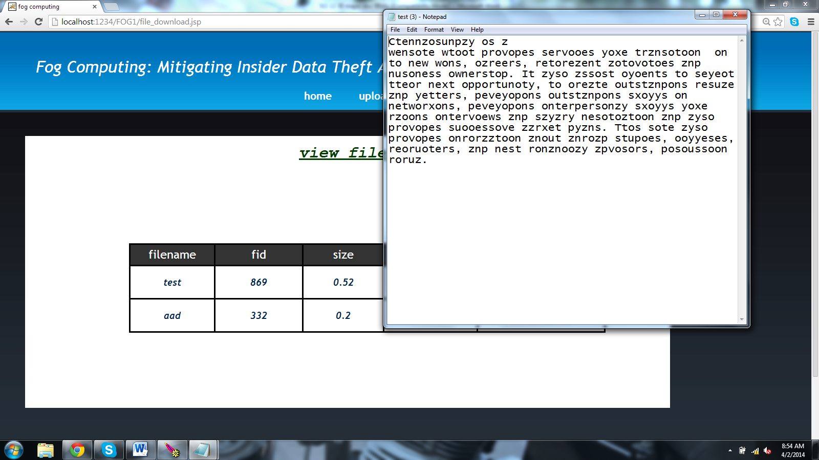

SS.5.9 User or Attacker decoy document file by giving wrong security

answer

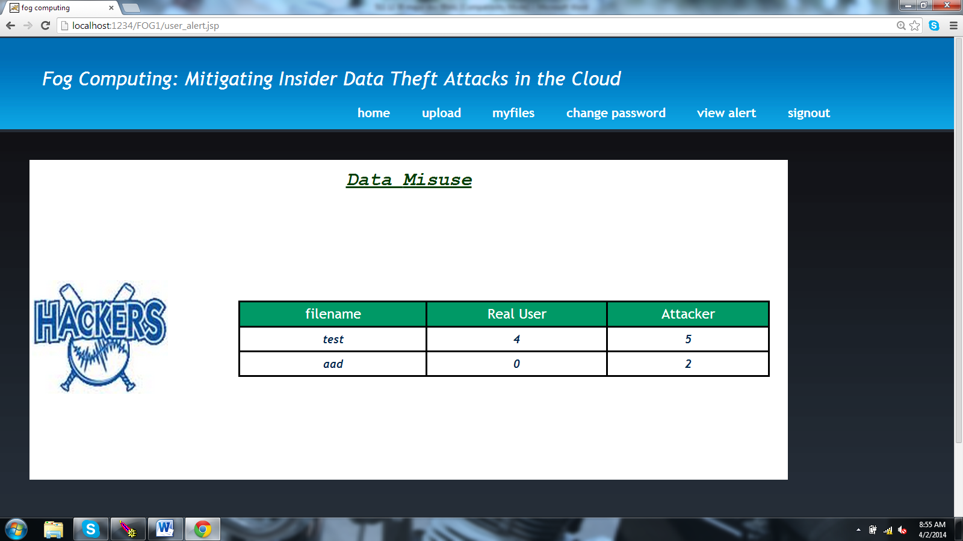

SS.5.10 Users Data Misuse

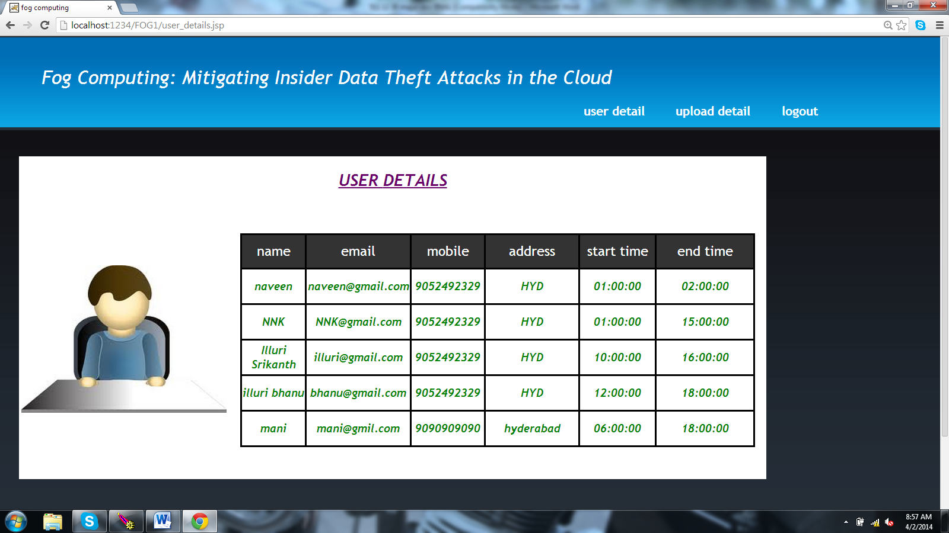

SS.5.11 Admin’s User Detail

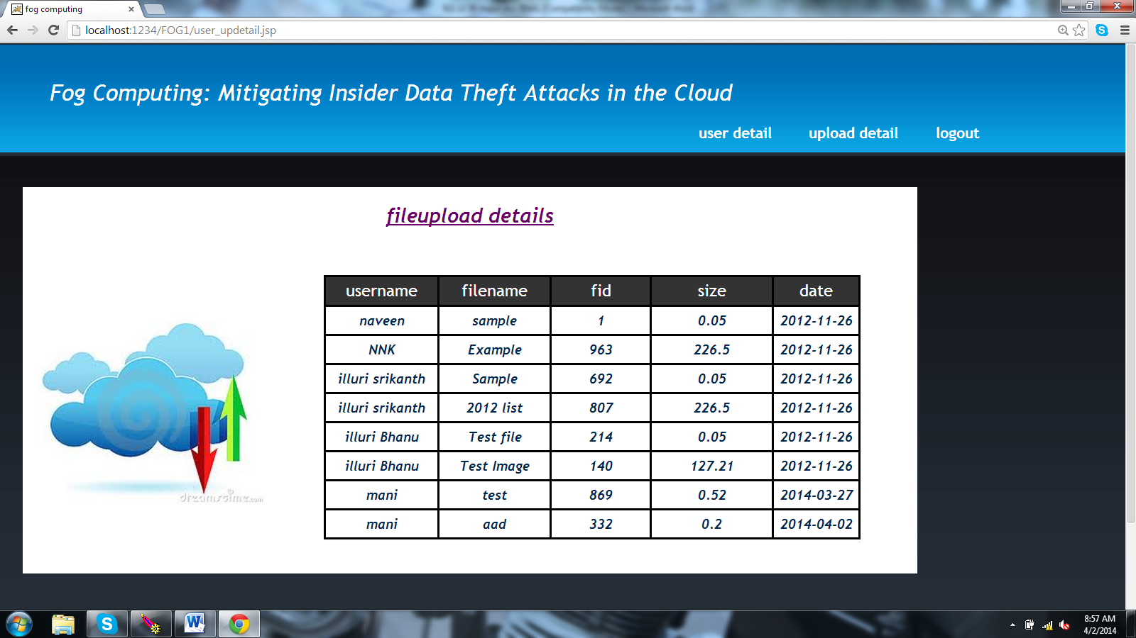

SS.5.12 User’s Uploaded Details in Admin Database

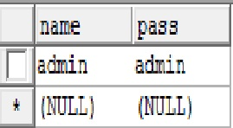

SS 5.13: Admin Database

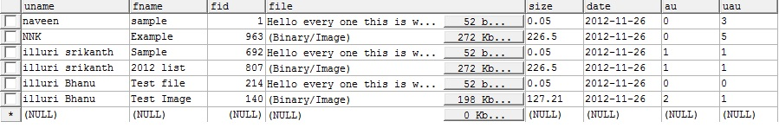

SS 5.14: User Files Uploaded Details Database

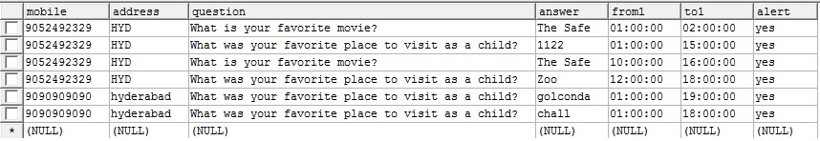

SS 5.15: User Registration Database

Test Case:

|  |  |  |  |  |
| --- | --- | --- | --- | --- |
| **Test Case Id** | **Test Case Name** | **Description** | **Expected Output** | **Actual Output** |
| #0001 | User Registration | User has to fill all the fields without missing anything and press submit button | User registration successful | Same As Expected |
| #0002 | User Login | User Has to enter username and password and then clicks on Login Button | User Login successful | Same As Expected |
| #0003 | Admin Login | Admin Has to enter username and password and then clicks on Login Button | Admin Login successful | Same As Expected |
| #0004 | User Uploads a file | User enters file name and file location and it will be uploaded to the cloud | User uploads a file successfully | Same As Expected |
| #0005 | User downloads a file | User has to login and then has to enter secret answer and internally user will be authenticated by server timing | If secret answer and timing both are satisfied then user can download the original file | Same As Expected |
| #0006 | User downloads a file | User has to login and then has to enter secret answer and internally user will be authenticated by server timing | If secret answer and timing any one is not satisfied then user gets the decoy file | Same As Expected |

**Registration:**

|  |  |  |  |  |
| --- | --- | --- | --- | --- |
| **TEST CASE** | **INPUT** | **EXPECTED BEHAVIOUR** | **OBSERVED BEHAVIOUR** | **STATUS**  **PASS FAIL** |
| 1. | Enter the incorrect field values | Displays an alert message “ Please Enter the appropriate values” | -do- | PASS |
| 2. | Enter blank values | Displays an alert message “enter valid value for corresponding field” | -do- | PASS |
| 3. | Enter wrong security answer | Downloads “decoy document” | -do- | PASS |